# Report for Shea Palmer (2024-10-01 to 2024-10-31)

Average Bat Speed: 56.51

Average Rotational Acceleration: 9.64

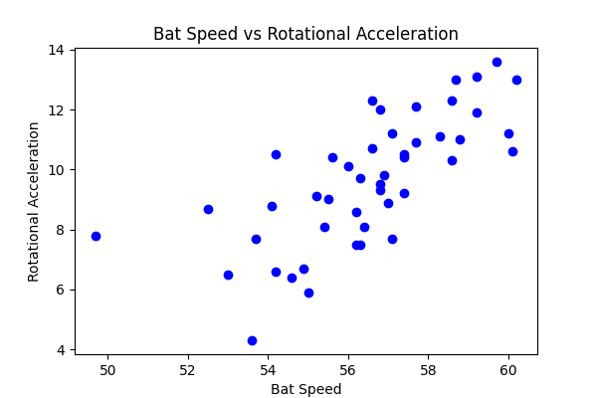

## Comments

Add comments here...